Credential AREA: Infant-Toddler Credential (Level 2)
TOPIC: HSW Domain-Specific Assessment Example
Interaction Observation & Checklist

I. Assessment Competency & Standards Alignment

Gateways Competencies Assessed | Competency Alignment by citation
Gateways Competencies Assessed | Zero to Three (2016)
ITC HSW1: Identifies infant/toddler mental health, nutritional and safety concerns | -------

II. Assessment Task Description/ Directions

This assessment will evaluate your ability to describe interactions within an infant/toddler environment for its capacity to support young children’s development in a developmentally-, individually-, and culturally-responsive way. You will use the information gathered via observation to establish recommendations for an early childhood environment regarding the support of developmentally-, individually-, and culturally-responsive interactions.
Technology Option:
- If a site is unavailable, or a common experience is needed, here is a video: 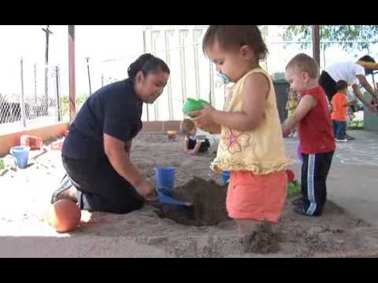 or 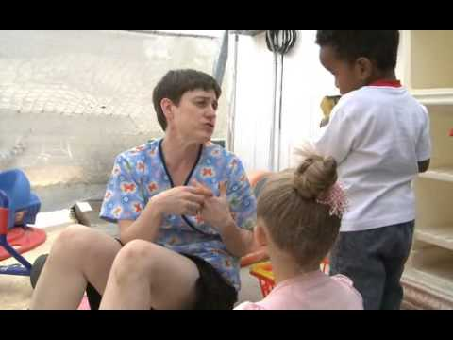 or 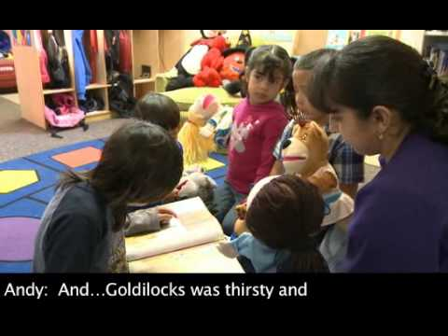 (Spanish)

Part I: Interaction Observation & Checklist:
Through your clinical site or other licensed child care facility:
- Arrange a date/time to visit to complete the Environmental Interactions Observation Checklist (see below)
- Collect evidence as available (e.g. pictures, sketches, examples, documents, etc.)

Part II: Post-Interaction Observation & Checklist Reflection:
Summarize the results of your completed Environmental Interactions Observation Checklist. This summary should include an overview of observed program practices related to:
- Supportive interactions with infants and toddlers during care-giving routines, including eating and sleeping
- Supporting a child’s individuality, including preferences related to interactions with the environment and caregiving interactions

Part III: Recommendations
Based on knowledge of developmentally appropriate practice, data collected, and the above suggestions, provide recommendations for each for the following:
- What strategies would you suggest for infusing developmentally-responsive interactions into daily routines?
Technology Option:
- Video/audio record options
- Collaboration options
- What strategies would you suggest for infusing individually-responsive interactions into daily routines?
- What strategies would you suggest for infusing culturally-responsive interactions into daily routines?

III. Assessment Rubric
ITC Health, Safety & Wellness Master Rubric
Competency | Distinguished | Competent | Developing | Unsatisfactory | Unable  to Assess
HSW1: Identifies infant/toddler mental health, nutritional and safety concerns  Zero to Three: N/A | Identifies behaviors and other symptoms that signal a possible nutritional concern in infants and toddlers  Lists health problems and concerns common in infants and toddlers (e.g., ear infections, thrush, teething) and defines appropriate associated precautions  Lists nutrition needs specific to infants and toddlers and gives examples of associated appropriate practices  Lists examples of possible mental health, health, nutritional and safety concerns in all infants/toddlers (e.g., prenatal diet), including children of varying abilities  Lists potential food-related health hazards for infants and toddlers (e.g., allergies, choking), and names steps to prevent dangerous situations  Outlines strategies to support families in identifying infant/toddler mental health, nutritional and safety concerns | Identifies behaviors and other symptoms that signal a possible nutritional concern in infants and toddlers  Lists health problems and concerns common in infants and toddlers (e.g., ear infections, thrush, teething) and defines appropriate associated precautions  Lists nutrition needs specific to infants and toddlers and gives examples of associated appropriate practices  Lists examples of possible mental health, health, nutritional and safety concerns in all infants/toddlers (e.g., prenatal diet), including children of varying abilities  Lists potential food-related health hazards for infants and toddlers (e.g., allergies, choking), and names steps to prevent dangerous situations | Identifies behaviors or symptoms that signal a possible nutritional concern in infants and toddlers  Lists health problems and concerns common in infants and toddlers (e.g., ear infections, thrush, teething)  Lists nutrition needs specific to infants and toddlers  Lists examples of possible mental health, health, nutritional and safety concerns in all infants/toddlers (e.g., prenatal diet)  Lists potential food-related health hazards for infants and toddlers (e.g., allergies, choking) | Provides incomplete or inaccurate identification of infant/toddler mental health, nutritional and safety concerns
Yellow = Level 2

IV. Data Collection & Analysis Tool

Competency & Standards Alignment |  | Cumulative Assessment Data
Competency | Zero to Three (2016) | Distinguished | Proficient | Needs Improvement | Unsatisfactory | Unable to Assess
ITC HSW1: Identifies infant/toddler mental health, nutritional and safety concerns | -------

Interactions & Observation Checklist
Date:
Observation Site:
Notes:
Caregiving Interactions Observed | Description | Comments/Analysis

Checklist
Routines | Observed | Notes
Routines include attention to child’s unique temperament needs | - Yes  - No
Routines respond to child’s social and emotional development | - Yes  - No
Routines are culturally responsive and individualized based on family preferences (e.g., does the family value dependence or independence?) | - Yes  - No
Routines are adapted to each child’s individual needs | - Yes  - No

